5

Model Development Phase Template

|  |  |
| --- | --- |
| Date | 18 June 2024 |
| Team ID | 739990 |
| Project Title | Auto Insurance Fraud Detection |
| Maximum Marks | 4 Marks |

# Initial Model Training Code, Model Validation and Evaluation Report

The initial model training code will be showcased in the future through a screenshot. The model validation and evaluation report will include classification reports, accuracy, and confusion matrices for multiple models, presented through respective screenshots.

# Initial Model Training Code:



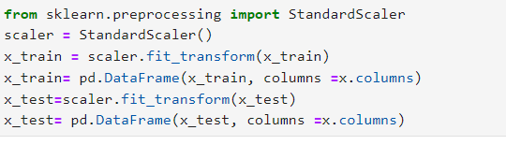

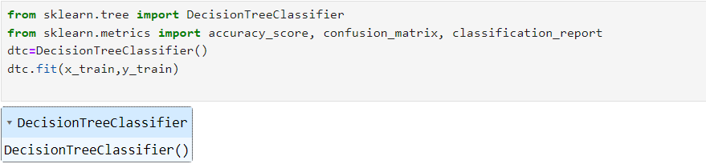

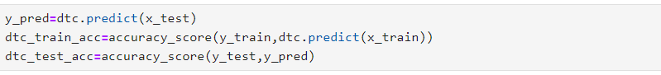

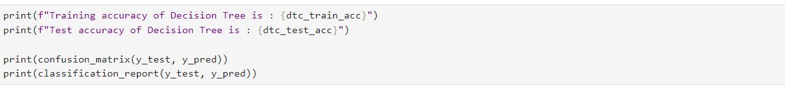

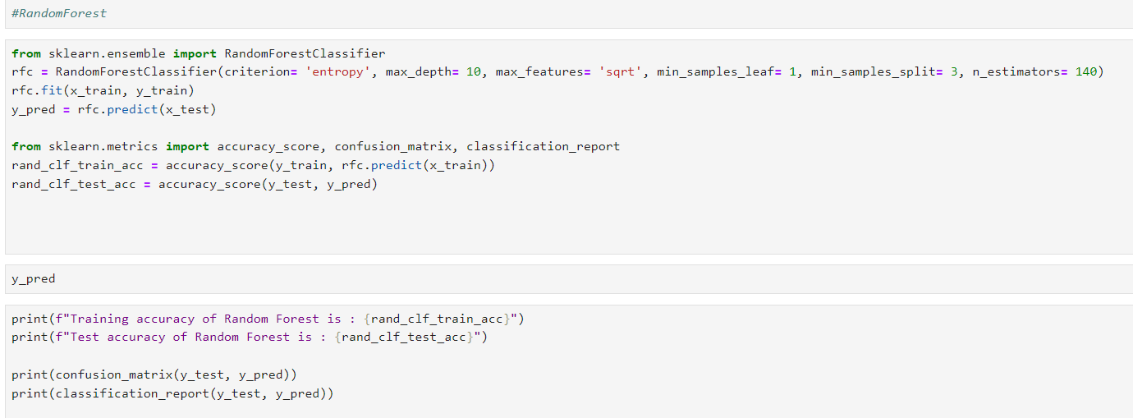

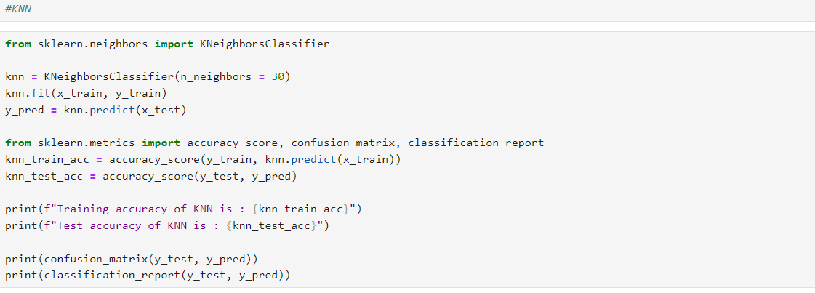

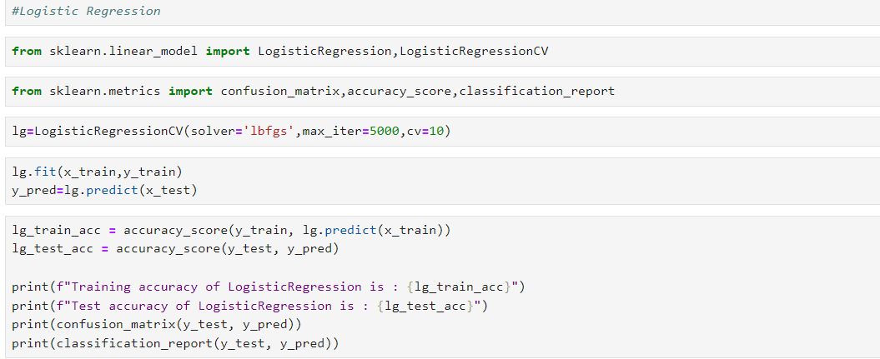

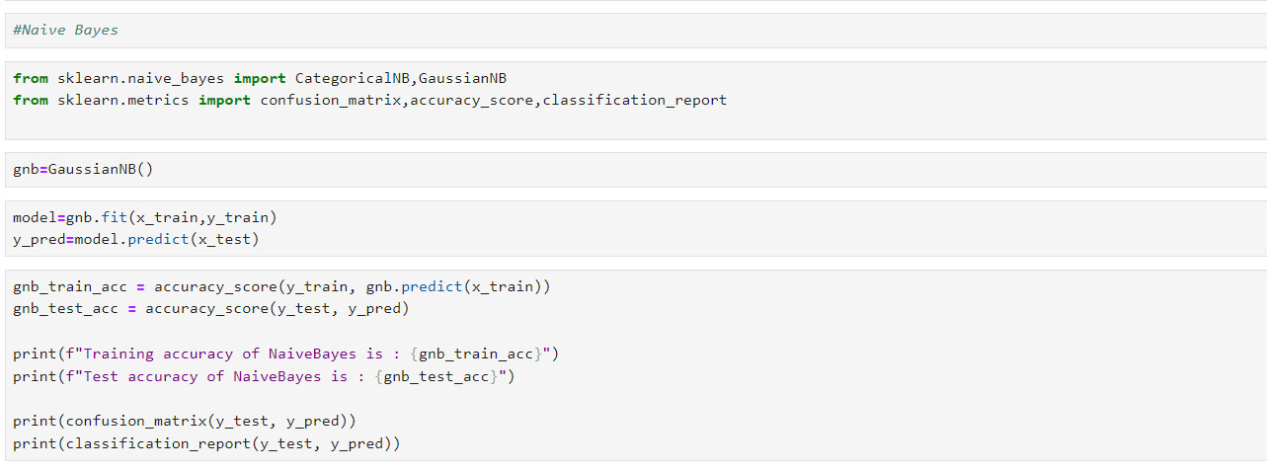

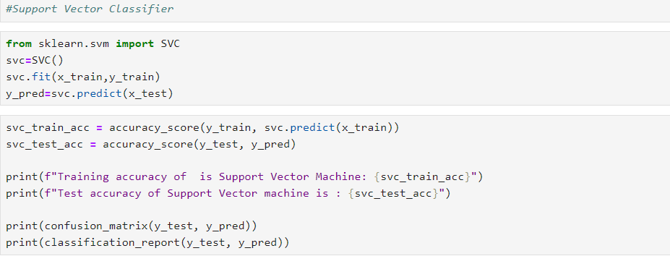

**Model Validation and Evaluation Report:**

|  |  |  |  |
| --- | --- | --- | --- |
| **Model** | **Classification Report** | **F1**  **Scor e** | **Confusion**  **Matrix** |
| **Decision Tree** |  | 68% | - |
| **Random Forest** |  | **64%** | **-** |
| **KNN** |  | **37%** |  |
| **Logistic Regression** |  | **64%** | **-** |
| **Naive Bayes** |  | **54%** | **-** |
| **Support Vector**  **Classifier** |  | **72%** |  |